Lesson 16.4 Study Guide: Homeostasis and Cells
Read section 16.4 (pgs. 482-485)

- All living things, unicellular and multicellular, need to do what in order to maintain homeostasis?
Grow, Respond to the environment, Transform energy, and Reproduce

- What do multicellular organisms need to do, in addition, to maintain homeostasis?
Cells in multicellular organisms need to communicate with one another because they have become specialized for specific tasks.

- Complete the Analyzing Data: Mitochondria in a Mouse found on pg. 484 in the textbook. Make sure to read the excerpt too. Answer the questions below:
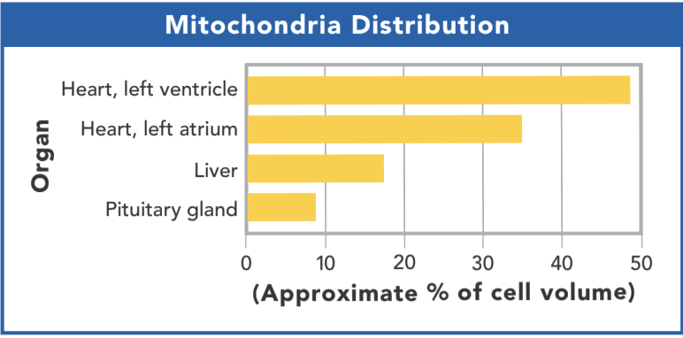
  - Compare the distribution of mitochondria in the four organs, or organ parts, shown in the graph.
The left ventricle of the heart has the most followed by the heart's left atrium. Liver cells have a medium amount and the pituitary gland has the least.

  - How is it useful for organisms to have an uneven distribution of mitochondria among their cells?
Some tissues have a higher need for energy because of its function and need more mitochondria. Where other tissues like in the pituitary gland have a different function and do not have the same energy requirement.

  - Using the graph data, what does the amount of mitochondria in the left ventricle of the heart tell you about that tissue’s function in your body?
The heart pumps blood throughout the body and has to generate enough of a push (force) to do this continuously therefore needing a high amount of mitochondria. (specifically the left ventricle does this)

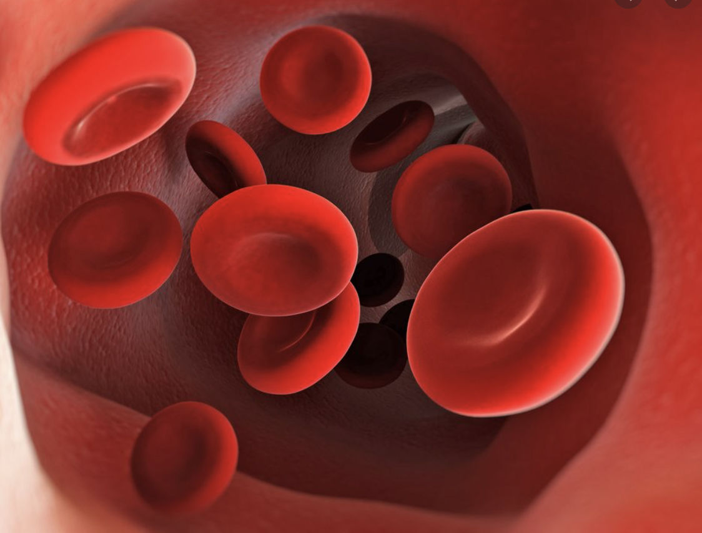
INFER: Structure and Functions: Not all eukaryotic cells are alike. Even in the same multicellular organism cells will differ in structure based on its function. Look at each of the 3 cells pictured and answer the questions that follow.

- The cells pictured are red blood cells and they are flowing through blood vessels. What is the function of red blood cells? _____To carry gases (oxygen and carbon dioxide) in the bloodstream to all cells_____. Relate how their structure/ shape of them help them complete their function _____red blood cells have a round, jelly-like shape (like an intertube) to easily flow through the bloodstream and ‘bounce’ off wall and other red blood cells__________
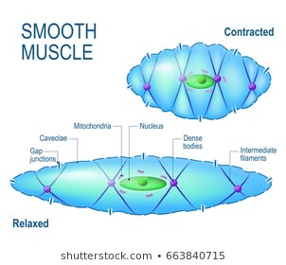
- This cell is a smooth muscle cell, as you see the cell changes shapes which takes energy. What does this cell contain more of to allow for its function (movement)?
Contains CYTOSKELETON for structure and movement of cells.
Contains MITOCHONDRIA for extra energy for movement
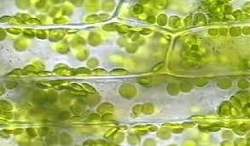
- This picture is a cell from a plant leaf. What is the function of a leaf (for the plant)?
____to absorb sunlight______. What does the leaf cell have more of to help
with its function? ____Leaf cells have more CHLOROPLASTS________
- Complete the assigned Interactive: Multicellular Life in google classwork.

- As you read the section on levels of organization in the textbook, fill in the table below to show how each idea is related to one another.

Specialized Cell | Definition: When cells differentiate and have different functions and shapes.
↓ | Example: Leaf cells have more chloroplasts for photosynthesis and root cells do not and have tiny hairs on the outside of the cells
Tissues | Definition: A group of similar cells that perform a particular function
↓ | Example: Many nerve cells (neurons) connect together to make nervous tissue
Organs | Definition: Many different groups of tissues working together, but each has a specific task.
↓ | Example: The brain is an organ that is made up of nerve tissues, fat tissue and blood vessels
Organ Systems | Definition: A group of organs that work together to perform a specific function
 | Example: The brain, spinal cord, and nerve throughout the body work together as the nervous system.

- With all these different specialized cells which form specific tissues, organs and organ systems, what must cells have in order to communicate with each other?
In order to communicate, cells must have RECEPTORS,

And where are these structures located on cells?
They are typically found on the outside of the cell’s membrane. Some may be found on the inside.

- How are communications sent between cells?
Cells communicate by means of CHEMICAL messages or signals

